**Registration Form**

***Leisure Marching Nationals***

***27 & 28 March 2026***

*Hosted by:*

***McCullough Guards***

***MainPower Stadium***

***289 Coldstream Road, Rangiora***

**Team Name**: _____________________________________________

**From (City/Town):** _____________________________________________

**Team Colours**: _____________________________________________

**Leaders Name:** _____________________________________________

**Coaches Name:** _____________________________________________

**Number in Team (including coach):** _____________________________

**Contact Details:**

**Name:** ____________________________________________

**Email:** ____________________________________________

**Phone:** _____________________________________________________

Are you flexible as to what day you can march? (circle) ***Yes*  *No***

If not, which day would you prefer to march: (circle) ***Friday*** ***Saturday***

**Note**, unlike other events, most teams will march on Friday with only a small number of teams scheduled to march on Saturday.

**Registration Form Cont.**

***Registrations close 31 December 2025.  
 Late entries will incur a $50 penalty.***

Registration: $35 per person (including the coach). $____________

Annual website maintenance % hosting fee (per team) $10.00

**Total Paid: $____________**

***Please make payment to the following account by 31 December 2025:***

**Name of Account:** POC Leisure Nationals 2026 **Bank:** Westpac

**Account Number:** 03-0823-0079741-017

Please enter the following reference details:

**Code:** “March Rego”

**Description:** Please enter your team’s name.

Please email your completed form to [Leisurenationals2026@gmail.com](mailto:Leisurenationals2026@gmail.com)

**Questions:** Please email [Leisurenationals2026@gmail.com](mailto:Leisurenationals2026@gmail.com)

Tracey McCullough 027 861 7212

(4.30pm – 8.00pm daily)

Note: PTO for more information

***We’d like to learn about your team and its members.***

***Please answer the following five questions***

1. **What is the name and age of the youngest person in your team?**

Name: ___________________________________________ Age: __________

1. **What is the name and age of the oldest person in your team?**

Name: ___________________________________________ Age: __________

1. **What year did your team form?** _______________________________
2. **What is the name of the person with the highest number of grand/great grand babies/mokopuna and how many do they have?**

Name: ________________________________________ Number: __________

1. 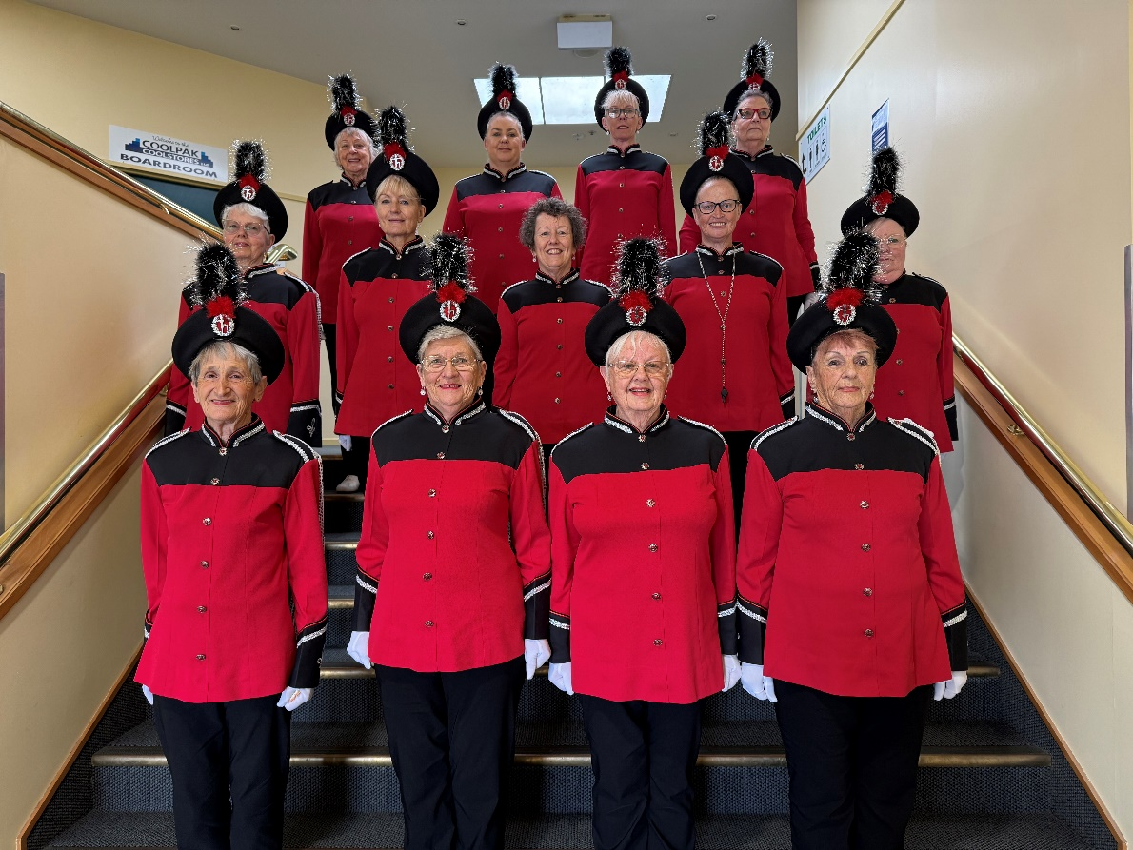**What is the average age of your team?** (To calculate this, write down the age of each person. Add all those numbers together. Divide this number by the number of people in your team). ___________________

***McCullough Guards look forward to hosting you.***