**MCCULLOUGH GUARDS Leisure Marching Team, Christchurch**

***Newsletter Number 1***

**LEISURE MARCHING NATIONALS**

**RANGIORA CANTERBURY, 27 & 28 MARCH 2026**

Kia ora koutou/Greetings fellow leisure marchers,

McCullough Guards are delighted to host our first national event in 2026. Welcome to your first newsletter where we aim to provide all the information needed for you to forward plan your travel and accommodation requirements.

I know many of you are excited that we are hosting this in Christchurch. Although Christchurch has many venues, there are few venues available that can seat up to 1000, as well as have a field size large enough to host 80 teams. Main arenas such as Wolfbrook, cost $26,000 per day to hire and this venue wasn’t available across the 6-week period we were seeking. We are delighted to have been able to secure the following venue for both the marching event, as well as the social function:

***MainPower Stadium, 289 Coldstream Road, Rangiora***

MainPower Stadium comes with plenty of parking for cars, vans, and coaches. There is a café on site, and they have assured me they can make 1000 coffees! They provide seating for 960 people, so once you are ready, please pop your bags back out in your vehicle and keep seats free for others. **No bags on seats please.**

The marching field will be laid with large 1m x 1m carpet tiles. The field is the size of two basketball courts so will easily cater for the largest team, as well as our grand finale Maze March.

I have included a map of the venue on the next page. This shows the court layout, seating, location of delegates meeting, café, toilets, and fire exits. Note I have placed 2 red circles – depending on which side has the most seating will be where the circle is located.

Please note the space for the delegates meeting is tight so ideally only one person from each team would attend. If you have good mobility and can stand, that would be helpful. We can cater for approx. 120 in this room, so those that need a little extra support are still welcome to bring another person along.

****We will not be doing any practice run throughs with teams. Unlike other events, most teams will march on Friday, and only a small number of teams will march on Saturday. ***Please ensure you plan to arrive in the Canterbury Region on Thursday.*** There are many locations for those teams wishing to have a practice, prior to their march. The Rangiora Show Grounds is right opposite MainPower Stadium and there are many parks and reserves in the local Waimakariri District.

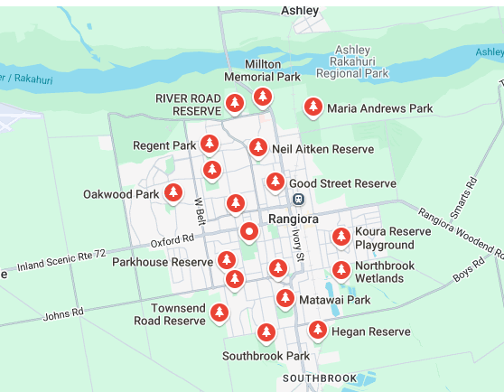

Your registration form is attached. We ask that all teams ensure they are registered by 31 December 2025 please. Please be respectful of this date which will allow us time to apply for the necessary funding we need to make this event a success.

As well as having a café on site at MainPower, Rangiora has 3 supermarkets, Countdown, New World, and Pak n Save. New World is the closest to MainPower Stadium. You can park in the New World car park and wander down the main street of Rangiora where you will find a wonderful range of shops. The Plough Hotel is great place for a cold beverage and a meal, as well as many other restaurants and fast-food outlets. I recommend you make a booking.

There are many accommodation venues to choose from in Rangiora. Alternatively close by is Woodend and Kaiapoi, or search accommodation in the Waimakariri District. Feel free to reach out if you need assistance on locations near the venue.

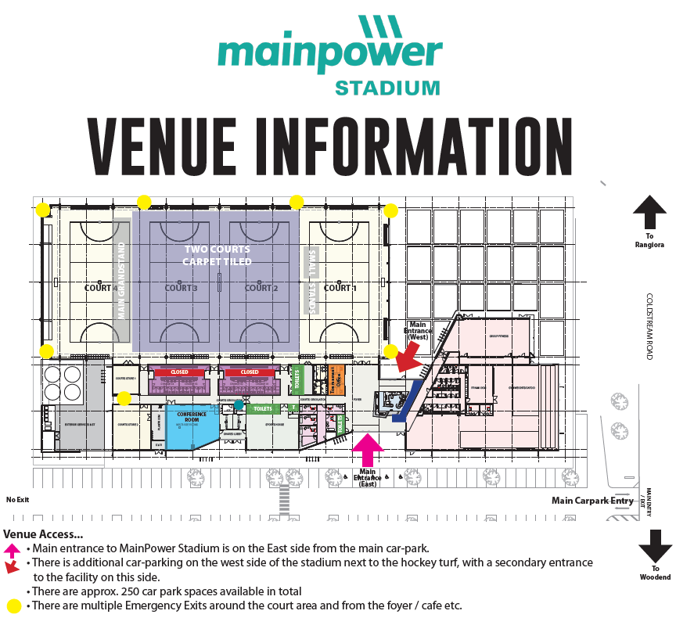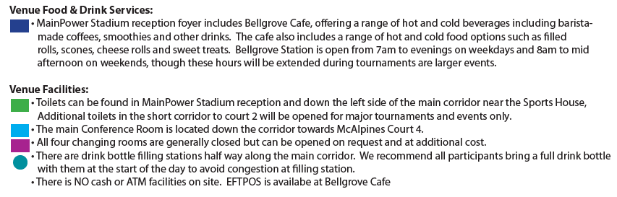

The red square is where the delegates meeting will be held. I will confirm in our next newsletter which way the field will face. Above are 2 circles. The circle will face the largest amount of seating.



**Event Run Times - DRAFT**

**Note: Actual times will be published in January 2026**

**Friday 27 March 2026**

|  |  |
| --- | --- |
| 8.30am | Doors Open  Hand in Music |
| 9.00am | Delegates Meeting |
| 9.30am | March Past |
| 11.00am | Teams 1-50 March |
| 5pm | Pack up |

**Saturday 28 March 2026**

|  |  |
| --- | --- |
| 8.30am | Doors Open |
| 9.00am | Teams 51-85 March |
| 1.00am | Maze March |
| 1.30pm | Flag Handover  Speeches/Presentation  Raffle Draw |
| 2.30pm | Doors Close |

**Saturday 28 March 2026**

**Social Function**

|  |  |
| --- | --- |
| 6.45pm | Doors Open |
| 7.00pm | Band Commences |
| 8.45pm | Supper |
| 11.15pm | Band Finishes |
| 11.30pm | Doors Close |



**The social function theme is,**

**AROUND THE WORLD IN 80 DAYS**

The registration for this event will be included with newsletter #2. Supper will be served to your table. Newsletter #2 will also confirm whether this will be BYO or bar service only.

**Souvenirs**

A small selection of souvenirs will be available via pre-order only. There will be other generic marching memorabilia available for purchase at the venue. All registered team members will be provided with a 2026 ribbon. The order form for souvenirs will be provided in newsletter #2.

**Raffles**

Raffles will be available for purchase. $5 provides you with one entry for all raffle draws. Scratchie Boards will also be available for purchase at $2 per ticket.

**Delegates Meeting**

If there are specific items you would like to be included at the delegates meeting, please email [leisurenationals2026@gmail.com](mailto:leisurenationals2026@gmail.com). If you are interested in hosting Leisure Marching Nationals in the South Island in 2028, please email [leisurenationals2026@gmail.com](mailto:leisurenationals2026@gmail.com).

**Music**

The format in which we require music will be confirmed in newsletter #2. I think it’s fair to say we all have CD’s and USB’s, but please also ensure you have an email version ready. These 3 formats mean you can cater for any venue, old or new. For those with CD’s and USB’s, it’s helpful to ensure only ONE track is on it please. This makes it much easier for the music person so please start working on this now.

**Team Photos**

Due to the cost of professional photographers, we have chosen not to have one in attendance at the venue. However, we will set up an area for team photos and will allocate a person to take these for you. You will need to provide your own camera or phone for this please. *TOP TIP of the day – take your photo before you march. This way you aren’t all red faced and out of breath.* Don’t forget to include your team flag in your photo.

**March Past and Maze March**

It is our intention that ALL team members participate in both the March Past and Maze March. We ask that march past is quick and efficient please to ensure the days runs to time.

**Contact Information**

If you have any questions, or need assistance, please feel free to contact us;

Email: [leisurenationals2026@gmail.com](mailto:leisurenationals2026@gmail.com)

Phone: Tracey McCullough on 027 861 721 (4.30pm – 8.00pm daily)

**McCullough Guards are excited to welcome teams to Rangiora.**

