Leisure Marching North Island 2025

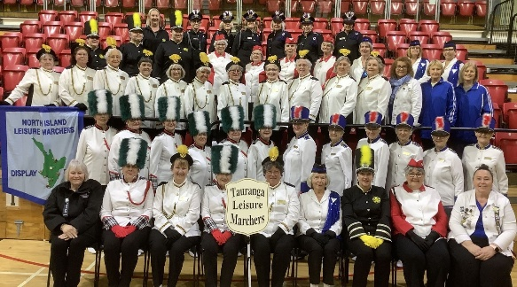Event Registration Form

Tauranga Leisure Marchers invite you to attend the Leisure Marching North Island Event to be held at the Lion Foundation Centre, Mercury Baypark Venue, Mount Maunganui

Date: Friday 17 & Saturday 18 October 2025

# Team Details

* Team Name: ___________________________________________________
* Team Leader: __________________________________________________
* Coach: _______________________________________________________
* Team Colours: _________________________________________________
* Number in Team: _________________________
* Team Contact: ___________________________
* Address: ______________________________________________________
* Phone Number: __________________________
* Email Address: _________________________________________________

Registration Fee: $25 per member (non-refundable)

Registration Deadline: Registrations close 30 June 2025

Payment Information: Payable to Tauranga Leisure Marchers Committee

Westpac Bank account number: 03-1548-0003543-000

Please use your **team name** as the reference.

Return this registration form to Brenda Potter at: taurangaleisuremarchers@gmail.com